./

**GENESIS**

Learning Outcome & Mini-project Summary Report

**EMBEDDED C**



|  |  |  |  |  |  |
| --- | --- | --- | --- | --- | --- |
| **Ver. Rel. No.** | **Release Date** | **Prepared. By** | **Reviewed By** | **To be Approved** | **Remarks/Revision Details** |
| 1 | 04-01-2021 | Aiswarya Sasikumar |  |  |  |
|  |  |  |  |  |  |
|  |  |  |  |  |  |
|  |  |  |  |  |  |
|  |  |  |  |  |  |

**Details**

**Learning Report-1**

Contents

Activity 1 Build process …,,…4

**ACTIVITY 2: LINKER SCRIPT………………………………………………………………………………………………………5**

**ACTIVITY 3: STARTUP CODE…………………………………………………………………………………………………….7.**

**ACTIVITY 4: MAKE FILE………………………………………………………………………………………………………… …9**

**GITHUB LINK…………………………………………………………………………………………………………………………..10**

# 

**ACTIVITY 1: BUILD PROCESS**

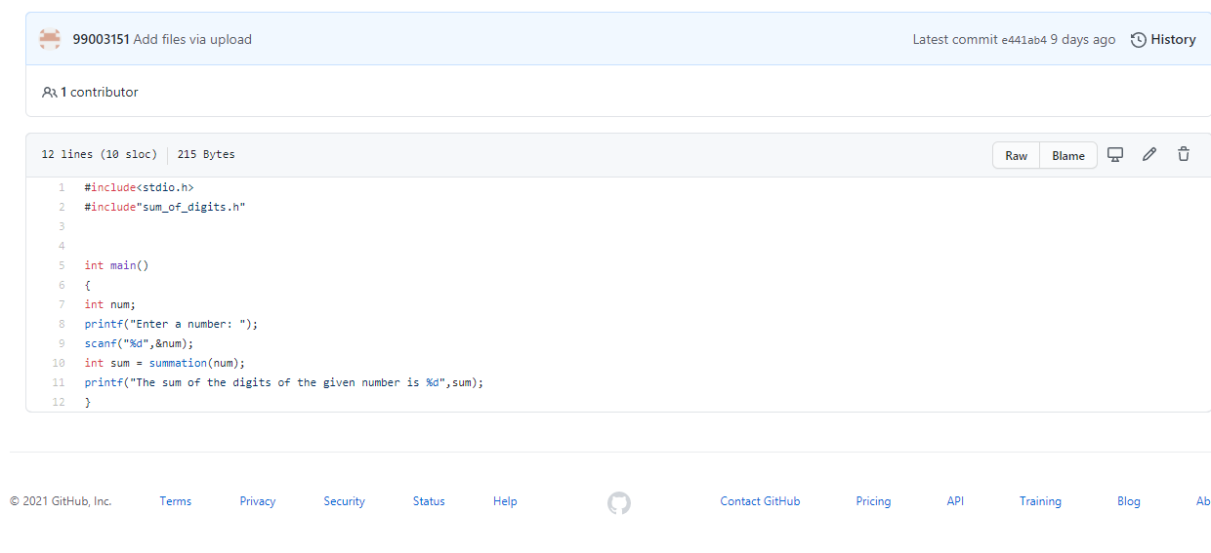

**ACTIVITY 2: LINKER SCRIPT**

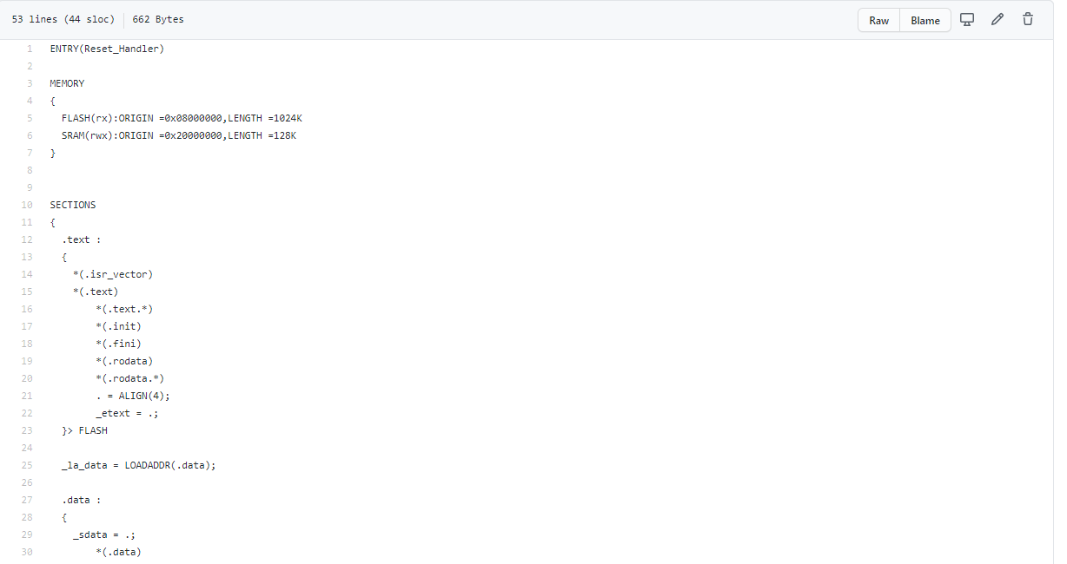

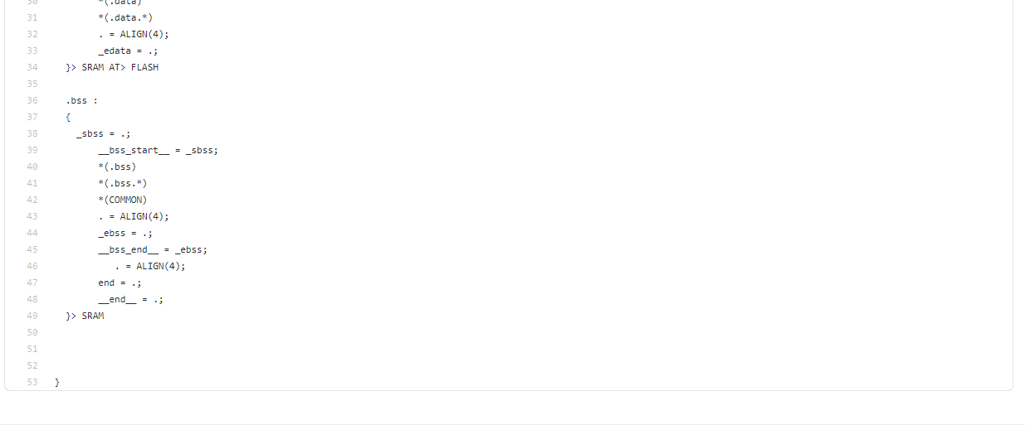

**ACTIVITY 3: STARTUP CODE**

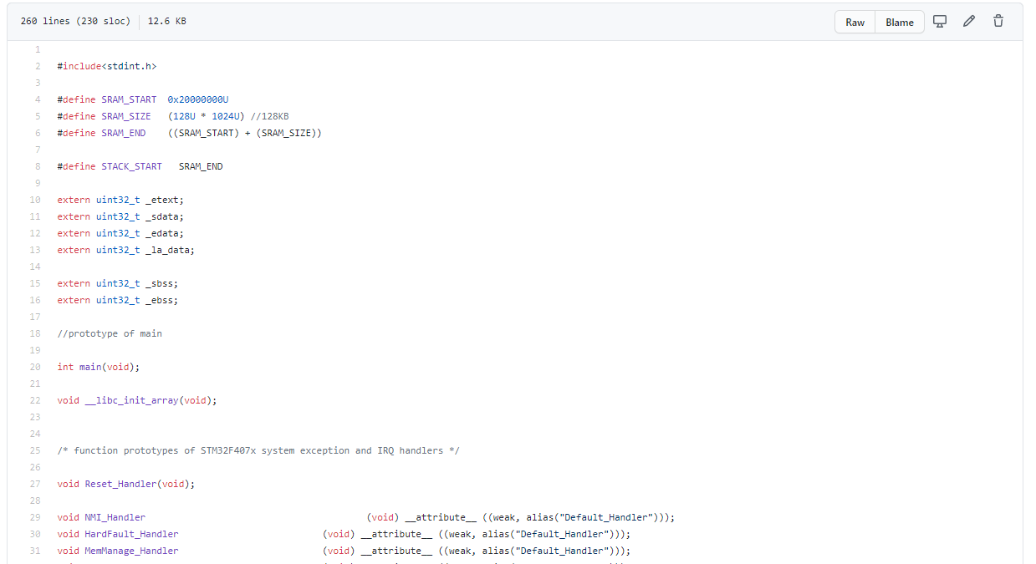

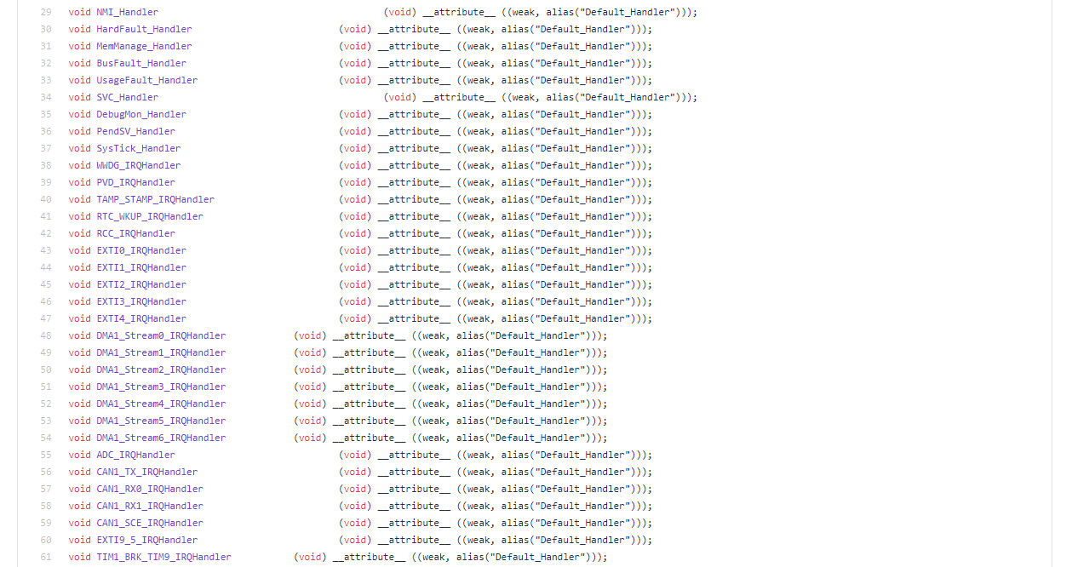

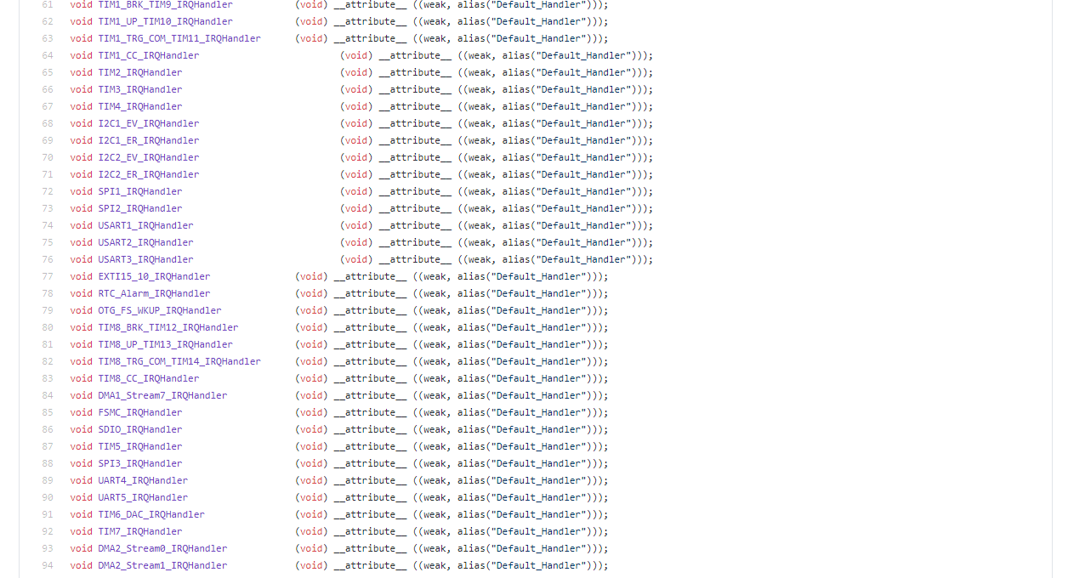

**ACTIVITY 4: MAKE FILE**

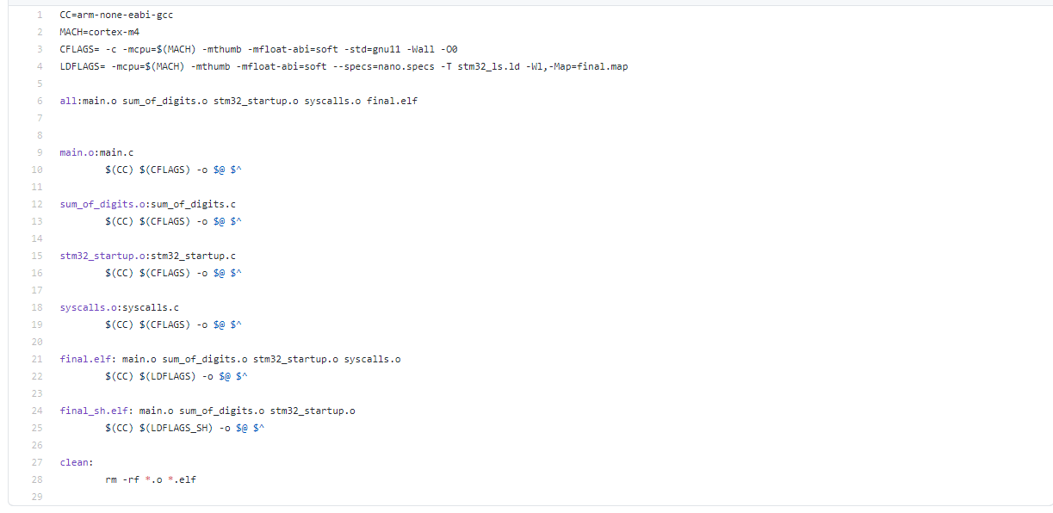

**GITHUB LINK: https://github.com/99003151/Embedded-C.git**